

**Course Information**

Course Title: Digital Image Processing

Section: 1

Course Instructor: Dr. Ahmed Wasif Reza

Associate Professor

Department of Computer Science & Engineering

**Lab-02**

**Student’s Information**

**Name:** Mujahidul Islam

**ID:** 2019-2-60-072

**Department:** Computer Science & Engineering

**Date of Submission: 27 October 2022**

**Question 1**

Determine the perimeter of an object by using 4 connected neighborhoods and 8 connected neighborhoods.

Code:

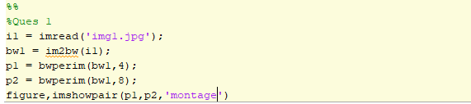

Output

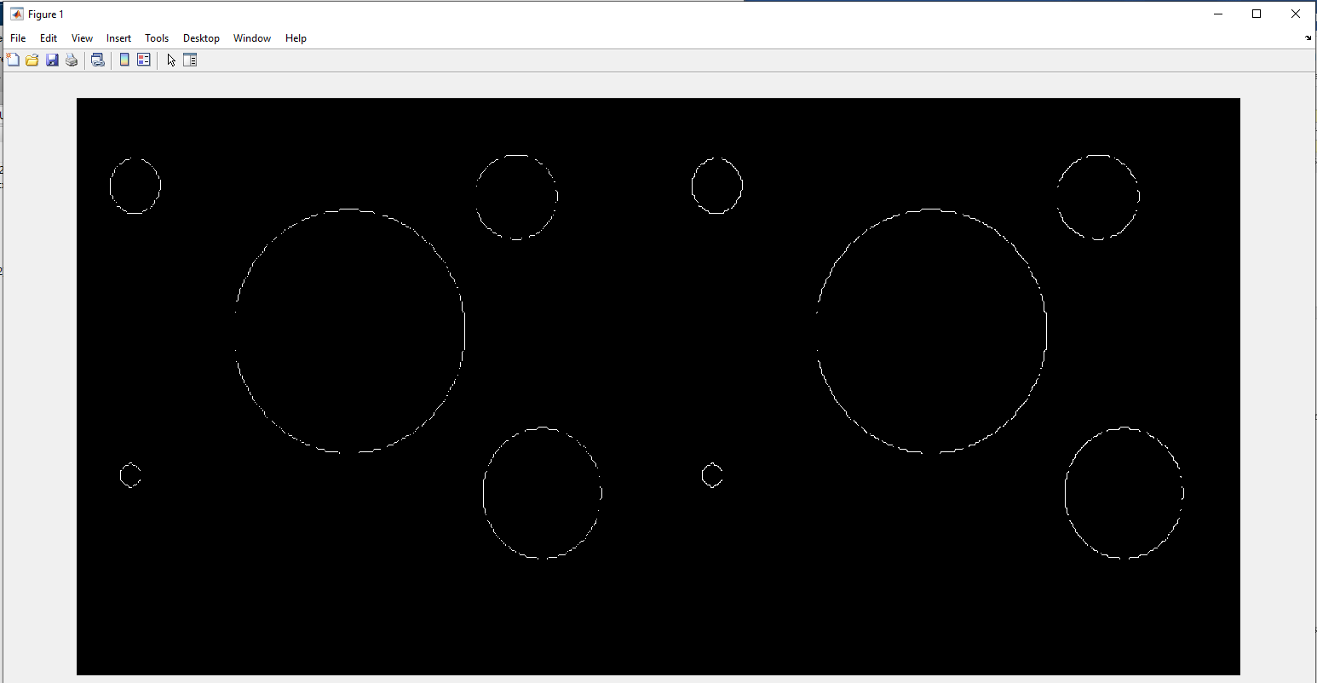

Fig: 4 connected neighborhood Fig: 8 connected neighborhood

**Question 2**

Create a binary image using threshold.

Code:

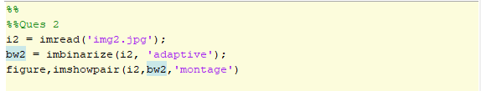

Output:

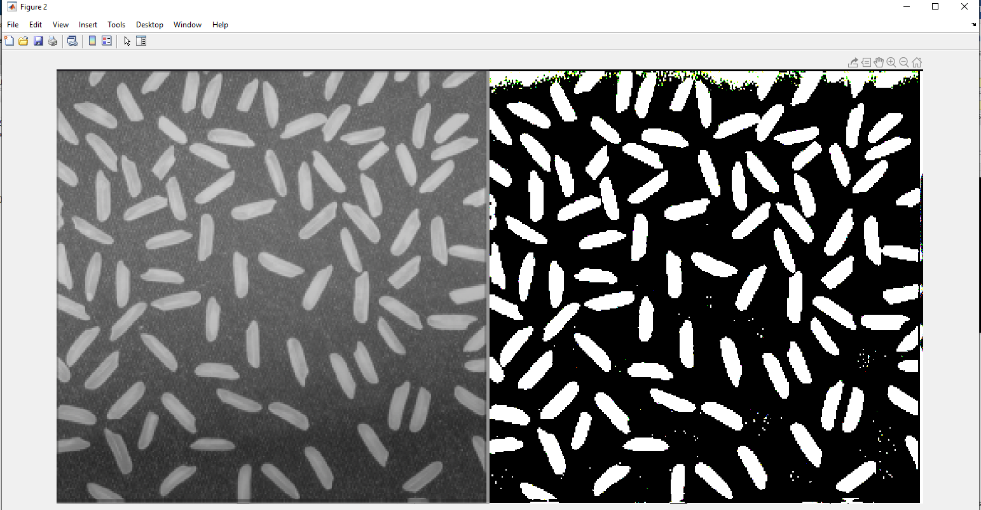

Fig: Grayscale image Fig: Binary image

**Question 3**

Determine the number of objects in the binary image generated in Question 2 using the concept of connectivity.

Code:

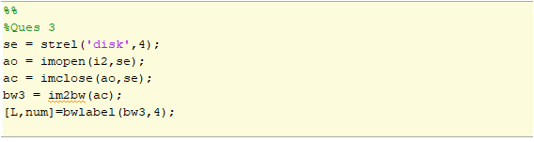

Output:

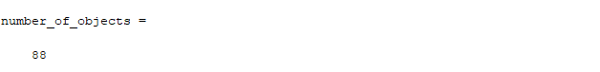

**Question 4**

Find the Euclidean distance between two points of the image.

Code:

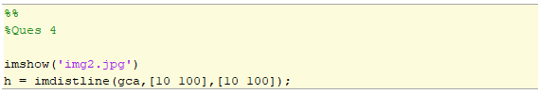

Output:

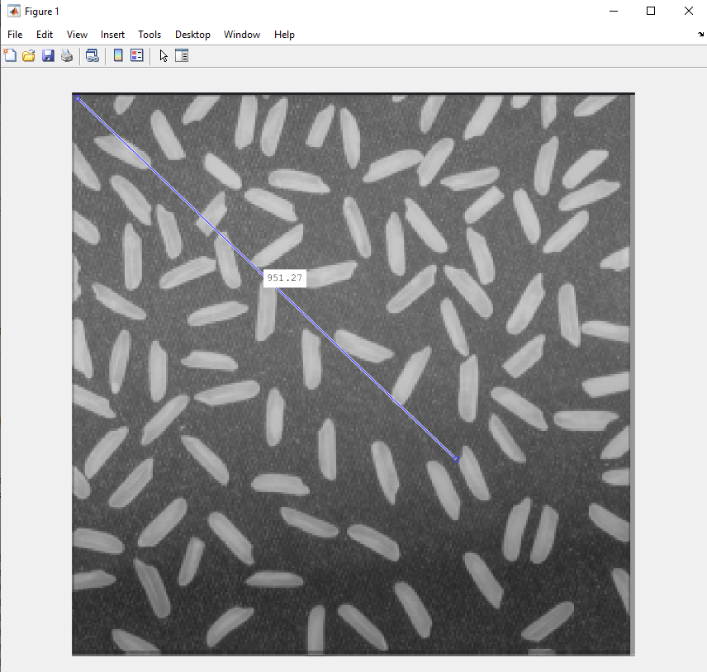

Fig: Distance shown in image

**Question 5**

Apply the following operations using img1 and img2.

a) Addition

Code:

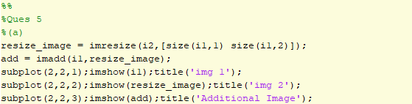

Output:

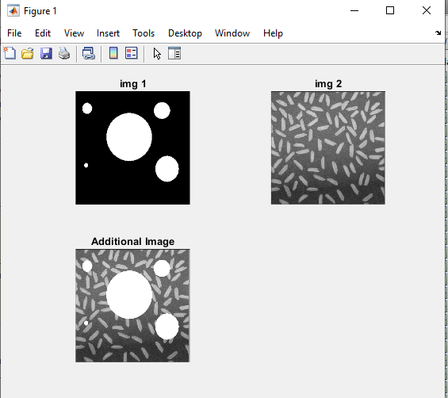

Fig: Both image and added image

b) Subtraction

Code:

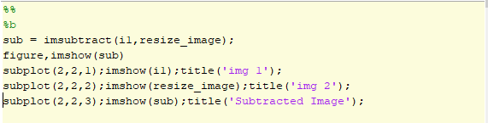

Output:

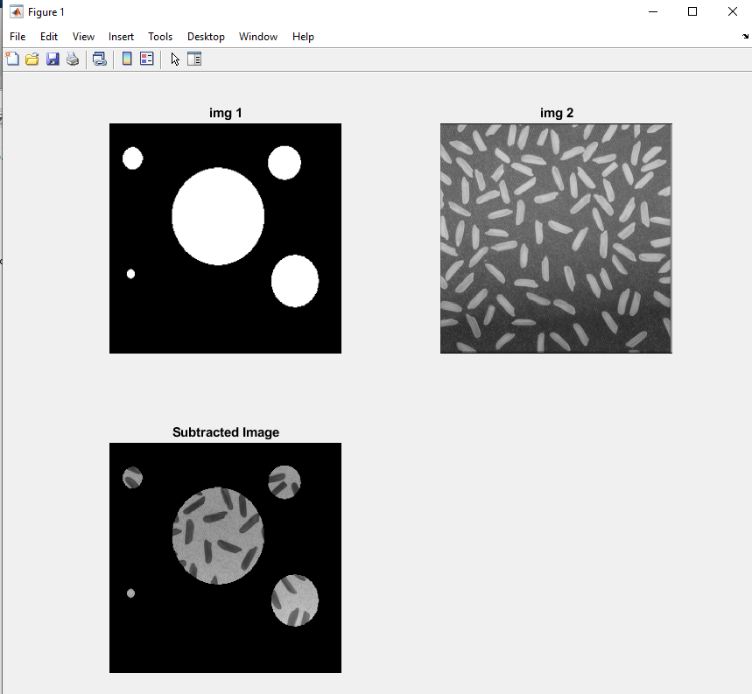

Fig: Both image and subtracted image

c) Multiplication

Code:

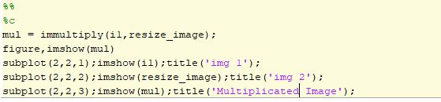

Output:

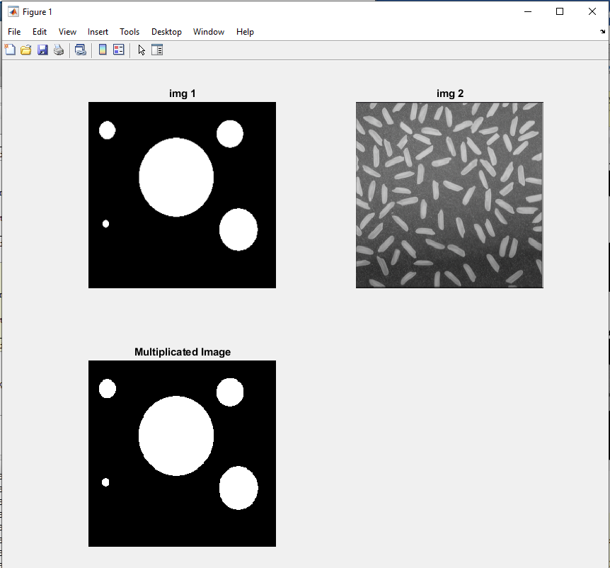

Fig: Both image and multiplicated image

d) Division

Code:

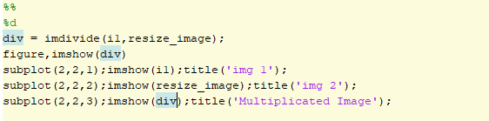

Output:

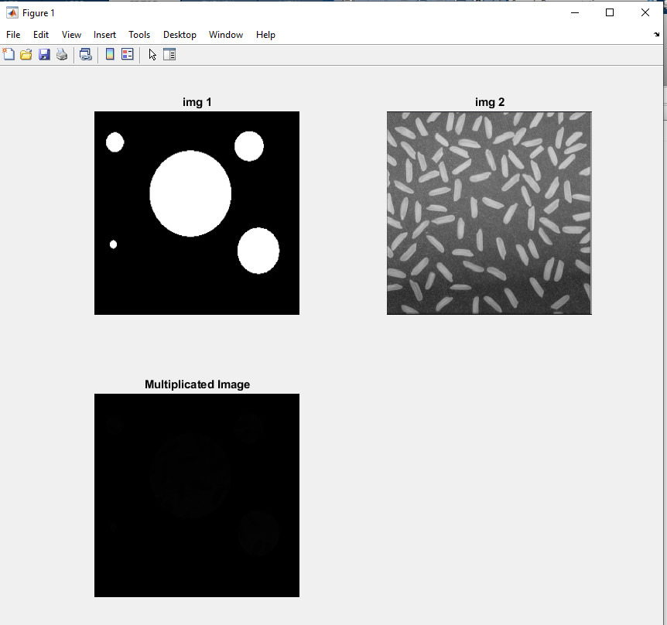

Fig: Both image and divided image

**Question 6**

Apply the following operations using img1 and img2.

a) AND

Code:

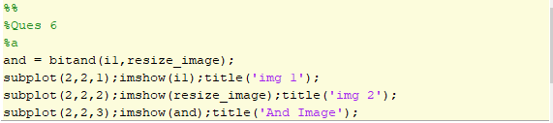

Output:

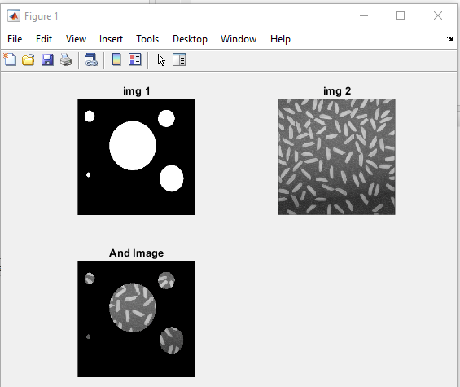

Fig: Both image and AND operation image

b) OR

Code:

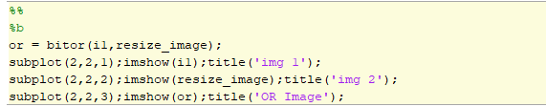

Output:

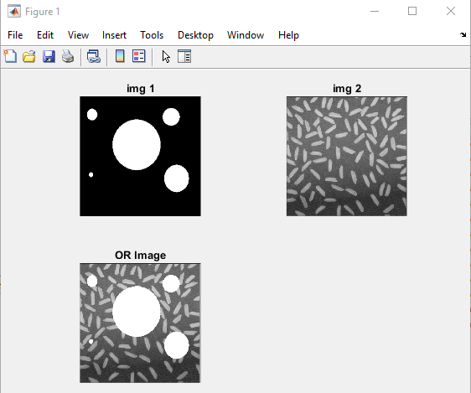

Fig: Both image and OR operation image

c) NOT

Code:

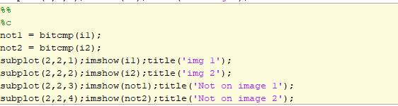

Output:

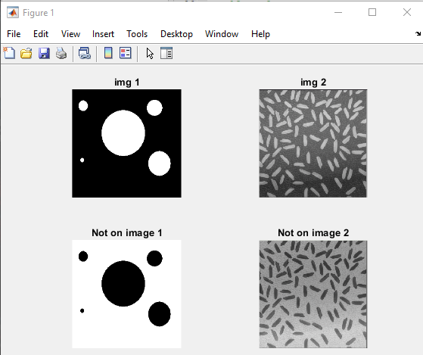

Fig: Both image and both NOT image

**Question 7**

Find the digital negative of the image.

Code:

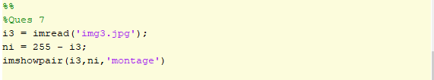

Output:

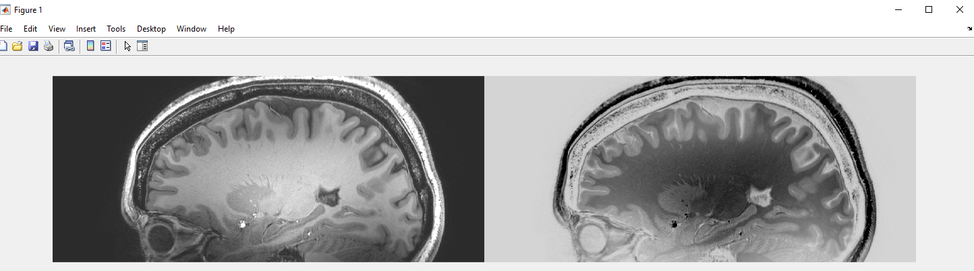

Fig: Normal image Fig: Negative image

**Question 8**

Apply bit plane slicing on the image.

Code:

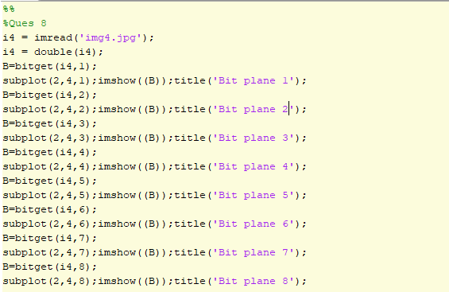

Output:

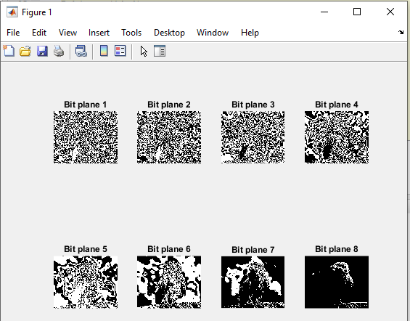

Fig: Plane slicing image

**Question 9**

Use contrast stretching on the image.

Code:

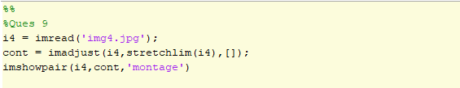

Output:

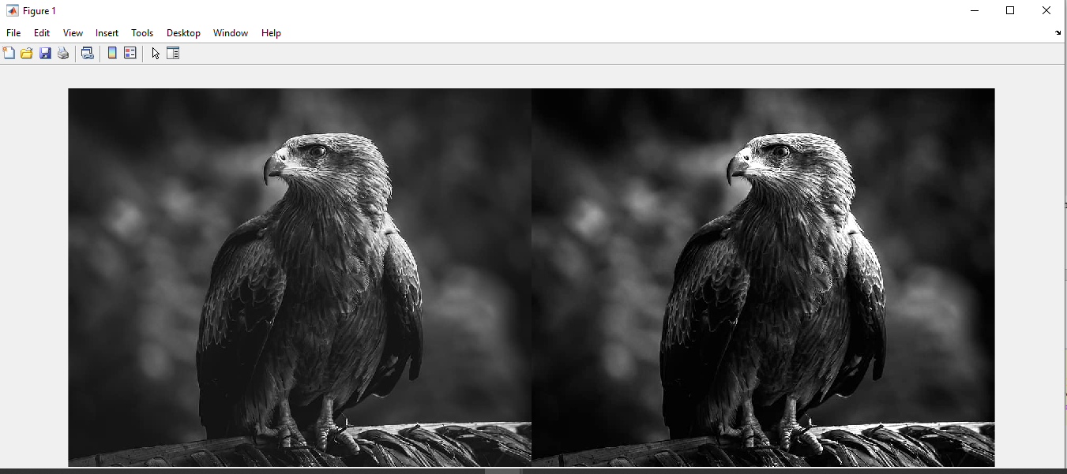

Fig: Normal image Fig: Contrasted image

**Question 9**

Change the contrast of the image using Logarithmic Transformation and Power-law Transformation.

Logarithmic Transformation

Code:

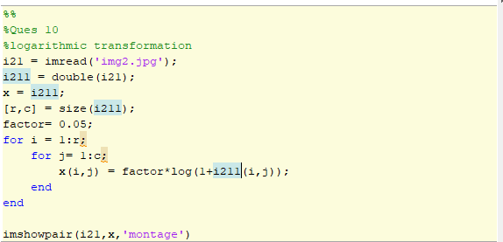

Output:

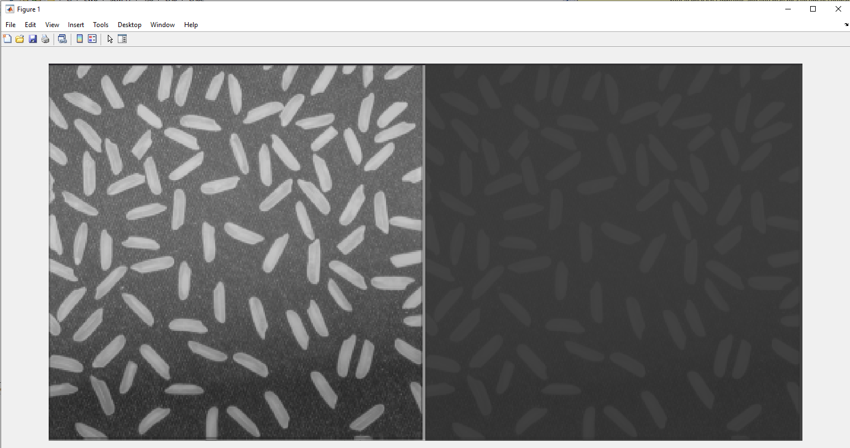

Fig: Normal image Fig: Logarithmic transformation

Power-law Transformation

Code:

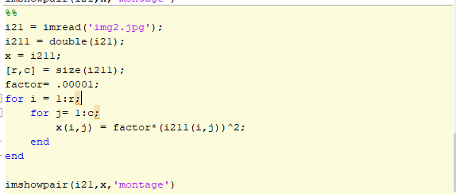

Output

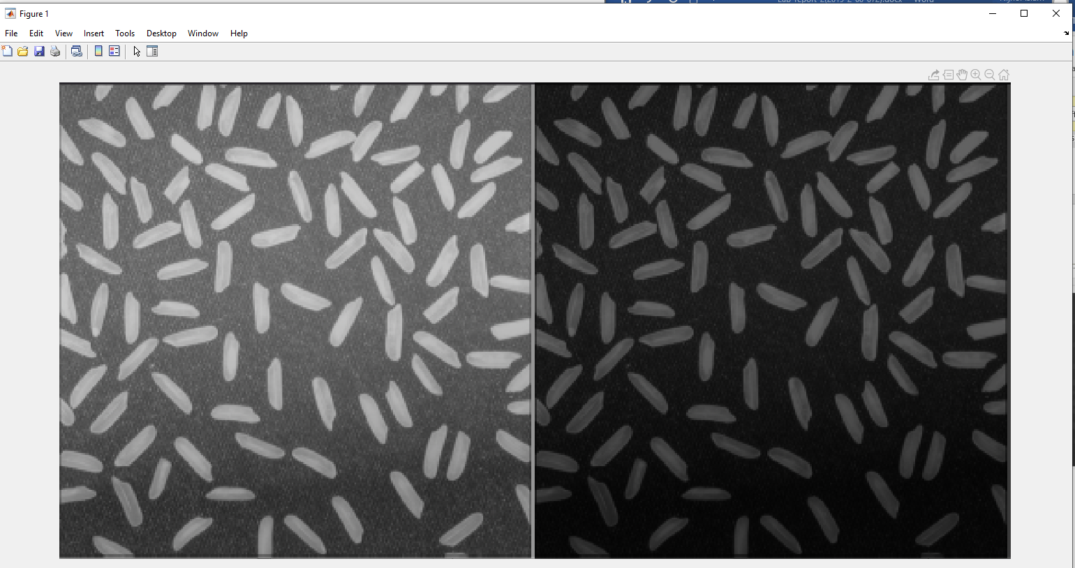

Fig: Normal image Fig: Power law transformation